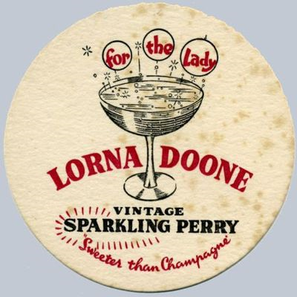

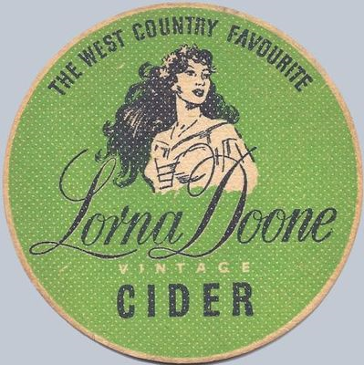

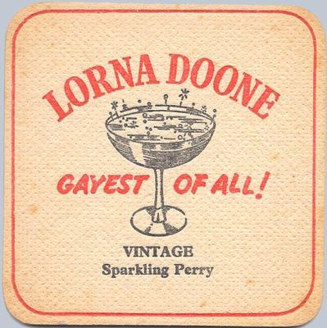

Ford Street had a thriving cider and Perry Factory, whose produce we are certain was drunk, not only in many local establishments, but especially in the Rising Sun Public House on the site of what is now “The Island”. Production continued until 1958, when it was taken over by Showerings, and apparently carbonated water was also sent from here to the Houses of Parliament. A filter tower, which may have been linked, still stands. There is still much evidence of the old cider production buildings, leats and underground culverts, although sadly production no longer takes place.